The RFID123 125kHz RFID Reader Board

Brought to you by:
ENGINEERINGSHOCK ELECTRONICS

FEATURES:
1) Internal EEPROM Memory Saves Data After Power Off
2) Can Save Up To 6x 125kHz RFID Cards
3) 2x Optional On-Board Relays For AC/DC Switching
4) Momentary & Latching Modes Of Operation
5) Indicator LEDs That Can Be Enabled & Disabled
6) On-Board Output Clearing Button
7) On-Board Buzzer To Indicate Indicate Incorrect Card Data
8) Can Directly Power An Arduino UNO
9) Can Be Powered Directly By An Arduino UNO
10) Connects Easily To An Arduino UNO

The RFID123 RFID Reader
Thank you for purchasing the RFID123 125kHz RFID reader. This detailed manual will show you how to program and use the RFID123. As well, you will be able to view the schematic diagram. This unit is easy to use, and also easy to customize! Thank you for your patronage!
Table of Contents
Included Parts (Parts Vary Depending On Purchase): 2
The Video Manual & Assembly Videos: 3
The Accessories: 3
The Wire Connectors: 3
The 2-Pin Header Connectors: 3
The 9v 1000mA (120-240VAC to 9VDC) AC-DC Power Adapter: 3
125kHz RFID Cards: 4
The RFID123 Diagram: 5
Hardware Blocks: 5
The DC Power Jack / Terminal Power Block: 5
The SEL Button: 5
The Mode Selection headers: 6
The Buzzer: 6
The Relay Enable Headers: 6
The Relay Output Terminal Blocks: 6
The Output Terminal & Indicator LED Bank: 6
The RFID Reader: 6
Schematic Diagram: 7
How to Connect To Arduino: 7
Sample Code: 8
RFID_Detect Code: 8
RFIDServo Code: 8
Extra Video Information: 9
Disclaimer: 9
Many Thanks! 9

Included Parts (Parts Vary Depending On Purchase):
1x RFID123 (Assembled or in DIY kit form)
9x Female-female ire connectors or female-male wire connectors
6x 2-pin Jumpers
6x 125kHz RFID cards
1-5x AC-DC 9v 1A wall adapters (depending on purchase)

The Video Manual & Assembly Videos:
I’m a visual person. The below manual gets down to the nitty-gritty, but the video manual really shows you the hands-on approach. Please take the time to watch it. I’ve also enclosed the assembly videos for those of you who are building from scratch. Part lists are talked about in these videos.
Video Manual:
https://www.youtube.com/watch?v=rziEuqLFjtU
Assembly Video:
https://www.youtube.com/watch?v=MhdS3Y5cll8

The Accessories:

The Wire Connectors:
These wire connectors allow for you to make connections between the RFID123 board and an Arduino Uno. Below is a picture of female-female connectors. You will also have the option of having female-male wire connectors shipped with your order.
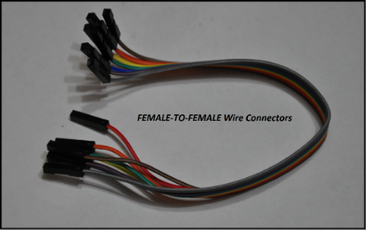

The 2-Pin Header Connectors:
These jumpers have several uses on the RFID123. Some are mandatory, and some are optional. This will be covered in great detail later on in the manual.
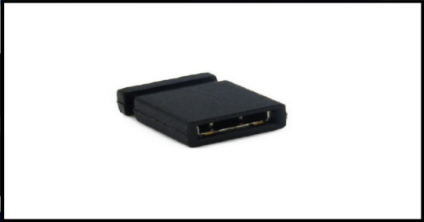

The 9v 1000mA (120-240VAC to 9VDC) AC-DC Power Adapter:
These power supplies are compatible with any input voltage between 120VAC and 240VAC (For those of you find people overseas). All you need to do is plug the AC adapter into the board. There is a 5mm power jack on the board, and the adapter plugs into the processor board directly.
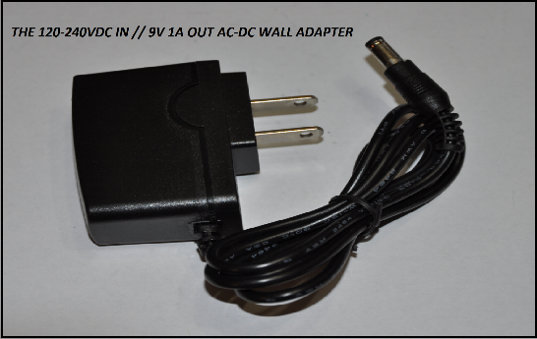

125kHz RFID Cards:
You don’t need to use these cards specifically if you do not want to. You can buy your own cards, or tags. All should be compatible as long as they are rated for 125kHz. Other cards, such as 13.52MHz will not work with the RFID123.
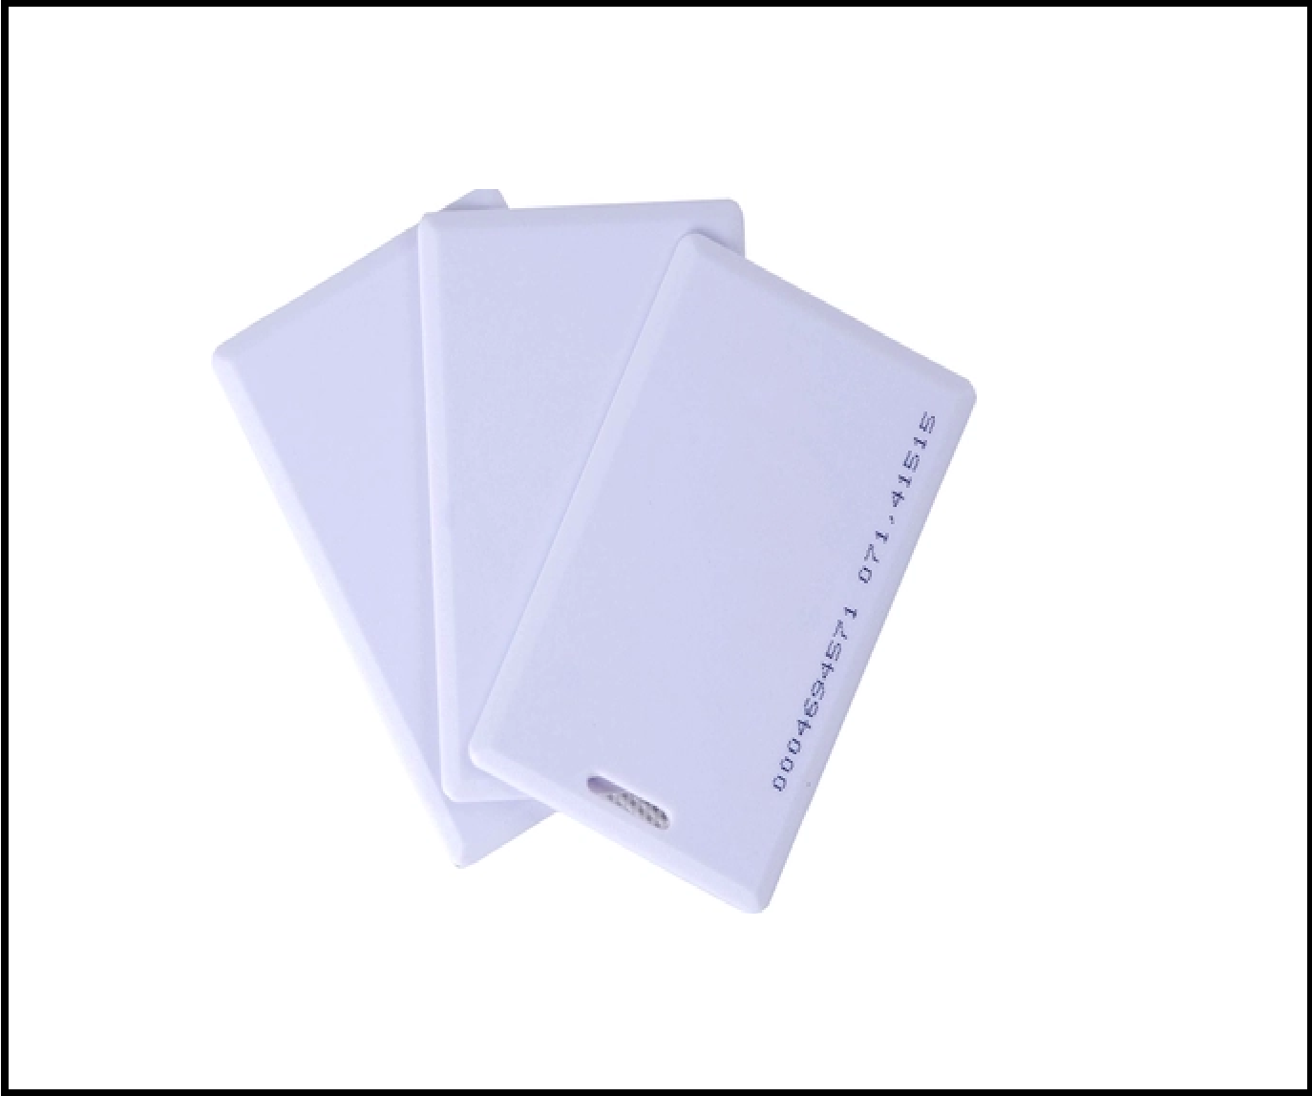

The RFID123 Diagram:
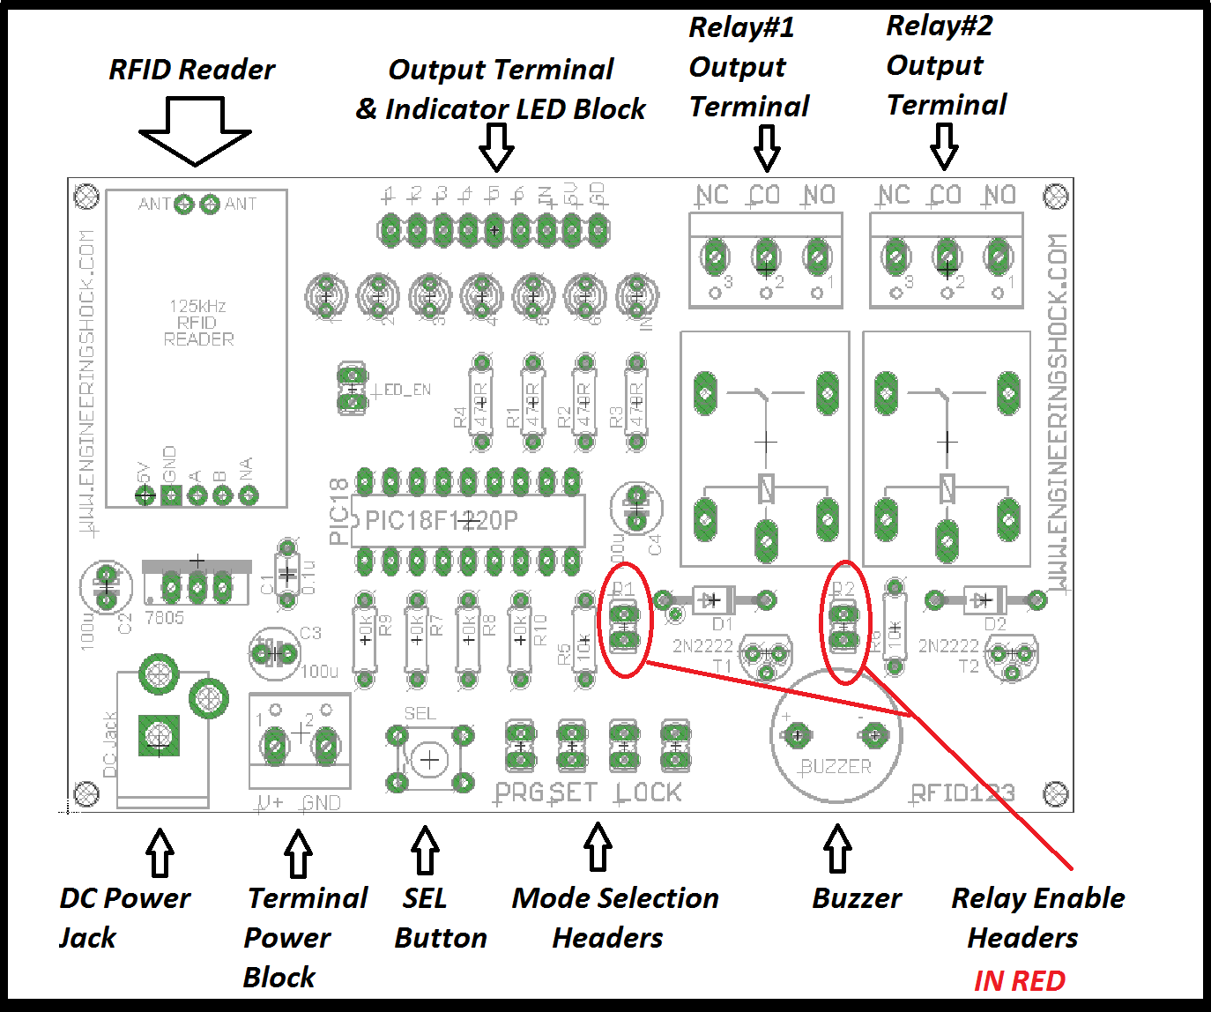

Hardware Blocks:

The DC Power Jack / Terminal Power Block:
You can power the RFID123 board in one of two ways. You can use the DC power jack or the terminal power block to supply power to the board. The RFID123 requires 8-10VDC @ 300mA or more. The 9v 1A AC-DC adapter that comes with some of the reward tiers plugs directly into the DC power jack. If you wish to use your own power supply, then you can use your own AC-DC wall adapter, or use a power supply through the terminal power block. Please note that two supplies cannot be used at the same time.

The SEL Button:
This button is only used in LATCHING MODE. It can be pressed to clear all of the outputs to 0v (low) state.

The Mode Selection headers:
There are four headers on in this area. The PRG header, which is used in program mode, the SET header, which is used to select between MOMENTARY and LATCHING modes, and the LOCK headers. The LOCK headers must be jumped after you've programmed in your RFID cards. When programming new card data, both LOCK headers should be left un-shorted by jumpers.

The Buzzer:
When an incorrect card ID is detected by the reader, the buzzer beeps three times, which acts as an audio indicator that you're using an incorrect card.

The Relay Enable Headers:
If you want to use relays to power high power DC / low power AC devices, then you need to enable them using the R1 and R2 headers. If you have the R1 and/or R2 headers shorted by a 2-pin jumper, then they will become enabled. Relay#1 corresponds to output#5/LED#5. When the card that corresponds to output#5 is detected by the reader, then relay#1 will turn on. Relay#2 corresponds to output#6/LED#6. When the card that corresponds to output#6 is detected by the reader, then relay#2 will turn on. The written manual will include detailed information on how to use these relay as high power switches!

The Relay Output Terminal Blocks:
These two terminal blocks are where you'd be connecting your high power switching. When a relay is off, then the CO (Common) pin is connected internally to the NC (Normally Closed) pin. When the relay is turned on, then the CO pin disconnects from the NC pin, and connects internally to the NO pin (Normally Open). Think of this as an on-off switch that is isolated from the rest of the circuitry.

The Output Terminal & Indicator LED Bank:
This is where you'd be connecting your external circuitry. You'd be using these pins to connect to your Arduino, PIC, Stamp, TTL circuit project, etc. Each output has its own LED indicator. You can disable the LED indicators by removing the LED_EN jumper. Output#1 through output#6 correspond to a specific programmed RFID card. The "IN" output corresponds to the logic on the blue indicator LED. This LED tells you when RFID data is being detected/received. When any given LED is on, then the relative output pin is at 5v logic. For instance, if the reader detects card data that matches card#5, then output#5 will go from 0v (low) to 5v (high), and LED#5 will turn on. If this is hard to follow, then simply watch the quick start video manual above!

The RFID Reader:
This little guy has an external rectangular antenna that reads RFID cards from up to 4cm away. You can put a plastic cover over the RFID antenna if you'd like. RFID cards will still be able to communicate with the reader with no problem!

Schematic Diagram:
Please note that a PDF copy of the schematic will be linked to the RFID123 project page at www.engineeringshock.com.
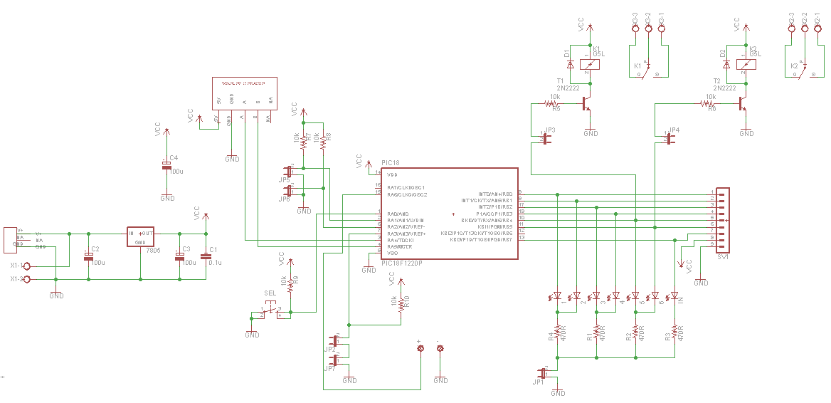

Programming & Using the RFID123:
Step#1: Remove power and ensure that that LOCK jumpers, the relay jumpers (R1/R2), and the SET jumper are all removed. This is very important. We are now going to program our RFID123 with card data!
Step#2: Ensure that a jumper is connected to the PRG header, and to the LED_EN header. This will place you into program mode, and to enable the indicator LEDS.
Step#3: Make sure that you have your RFID cards ready. You have to program in 6x slots. You can use the same RFID car for all slots if you’d like. Each memory slot can be allocated to different cards, or to the same card. For instance, if I have three cards handy, I can program in the same card for slots 1/2/3/4 and use the other two cards for slots 5 & 6. In any case, if you have questions, please refer to the video manual above. When you plug in power, if you’ve place a card over the antenna. Output#1 & LED1 will turn on for about a second, then turn off. The green indicator will also do this. Place another card on the antenna, when the indicator LED and LED1 have turned off, it means that that card was programmed into slot#1. Place another card on the antenna, and both the Indicator LED and LED2 will turn on for a moment, then turn off. Once you’ve programmed in card data for all six slots, the green indicator LED will turn on, and stay on.
Step#4: From here, your programming adventure is over. Remove power, but make sure to wait 5-10 seconds before applying power again. This will allow for the board to bleed off any voltage left on the capacitors. If you do not wait, the programming may be unsuccessful, and you might have to program in the cards again.
Step#5: Now that your cards have been programmed, test it out! Remove the PRG jumper, but leave the LED-EN jumper connected. Connect jumpers to both of the LOCK headers. If you do not do this, then your RFID123 will not function. Leave the R1/R2 headers with no jumpers on them. As well, leave the SET header without a jumper connected to it. To reiterate, you should have jumpers shorting both of the LOCK headers, the LED-EN header only. R1/R2 headers, the SET header, and the PRG header should be left without jumpers on them.
Step#6: Power your unit back up. With the SET header un-shorted by a jumper, you should be in LATCHING MODE. This means that when the RFID123 detects a card that is programmed into a card slot, then that relative output and output indicator LED will turn on/go from 0 to 5v. If the RFID123 detects that same card again, then said output will turn off. Simple as that. One card swipe turns it on, and another swipe of the same card will turn it off. If you have one card saved to more than one card slot, then all LEDs/outputs that have that card data saved to their slot will turn on, and turn off when that card is detected for a second time. In this mode, you can use the SEL button to turn off/clear all outputs/output LEDs.
NOTE: If after you follow step#5 and step#6 you find that the programming didn’t save. Don’t fret. It just means that you didn’t wait long enough after you removed power (after programming mode), and applying power again. The EEPROM memory in the PIC chip is finicky this way. You need to ensure that after you’ve powered your unit off after programming, that you wait a little while before powering back up in Latching or Momentary mode.
Step#7: Remove power and add a jumper to the SET header and power back up.
Step#8: You should now be in momentary mode. This means that when the RFID123 detects a card that has been saved to an output slot, then said output will turn on for about one second, then off again. The outputs do not latch in this mode. The SEL button has no purpose in this mode.
NOTE: The buzzer sill beep a couple of times and the green indicator will turn on in the even where an invalid card has been detected.
Step#9: In this final step, we will test the relays. As long as you aren’t in programming mode, then you can add jumpers to the R1/R2 headers. If you have these jumpers connected, then Relay#1 and Relay#2 have been enabled. As long as output#5 (Controls Relay#1) and output#6 (Controls Relay#2) are high (On), then the relative relay will be on. You can test the relays in either latching mode or in momentary mode. Bring the card that you have allocated to output#5 to the antenna. You should hear relay#1 click on and stay on if you are in latching mode, or click on and off if you are in momentary mode. Bring the card that you have allocated to output#6 to the antenna. You should hear relay#2 click on and stay on if you are in latching mode, or click on and off if you are in momentary mode. If you don’t know how relays work, then check out the Extra Video Information section of this document and check out the “How to control AC with relays” video, as well as the solenoid video.

How to Connect To Arduino:
You can easily connect your RFID123 to an Arduino. You can use one output pin, or all six if you’d like. There will be code samples offered and talked about later on. Here are some important steps to follow when interfacing with Arduino:
Connect the GND pin on the output block to one of the GND pins on your Arduino UNO. From there, you can connect the VCC pin on the output block to the 5v pin on your Arduino UNO if you’d like to have the RFID123 power your Arduino Uno. Make sure that you do not have these reversed!!! If you wish to use individual power supplies for your RFID123 and Arduino Uno, then the only thing that you have to do is connect ground to ground (GND to GND), and any output pin(s) on your RFID123 to the selected I/O ports on your Arduino Uno.
Alternately, if you wanted to power your RFID123 using a power source that is connected to your Arduino Uno, then again you have to connect the VCC/5v lines together and the ground lines together, as spoken about above. Plus in power to your Arduino Uno, and you’ll also be powering your RFID123! Neat, eh?

Sample Code:

RFID_Detect Code:
Have your Arduino Uno tell you which card has been read with this code. All you have to do is make the connections below, load the code called “RFID_Detect”, run the code and open the serial monitor. From there, you MUST ensure that you are in Momentary mode. If the RFID123 picks up a card that has been saved into memory, then the serial monitor will tell you which card has been detected. If an invalid card is detected, the serial monitor will also tell you this.
RFID123 Board Connects To Arduino Uno
5v 5v
GND GND
Output 1 4
Output 2 5
Output 3 6
Output 4 7
Output 5 8
Output 6 9
IN 10

Plug your Arduino UNO into your PC, and upload the code below to automatically run the script. Once running, open the serial monitor on your Arduino UNO. As long as both the Arduino UNO & RFID123 are powered, and the RFID123 in momentary mode, then the serial monitor will tell you which card has been detected.

Code:

RFIDServo Code:
This project allows for you to toggle a servo motor state for the sake of making an electronic lock. For this project, you will need a servo motor. I used a micro servo. You can find them for an inexpensive price on ebay. Follow this video demo for hook-up instructions:
https://www.youtube.com/watch?v=Omfbix3KwZA

Code:

Extra Video Information:
In this section, I will show you how to make wire extensions between the reader board and the antenna through video. I will also show you how to use the relays to control an electromagnetic solenoid for lock purposes. Lastly, I will show you how to use the relays to control AC devices.
Wire Extensions Video: https://www.youtube.com/watch?v=bEzdqTv3DHw
Electromagnetic Solenoid Lock Video: https://www.youtube.com/watch?v=ow7U5zA3OqM
How To Control AC devices With The Relays: https://www.youtube.com/watch?v=hW5u2P9QImU

Disclaimer:
This board is completely safe to use, but as soon as you put high power on the relays, then you have to consider your safety. If you have never worked with high voltage AC before, then please have someone with you when working with it. If you are not careful, the result can be disastrous. You could be seriously shocked, or even killed with high power AC mains. I will not be held accountable if you hurt yourself. Please be very thoughtful and careful when working with high power AC and have someone with you who knows what they are doing. Watch all of the videos, and educate yourself on AC voltage before attempting to connect AC mains to the RFID123 relays.

Many Thanks!
Many thanks for pledging to this kickstarter campaign/purchasing this set from my websites. I do appreciate your patronage! I hope that you enjoy working with this set, and that you’re able to implement it into your projects. Take care, and thanks again for taking the time to read through this document.

