The Multi-Program Laser Security Tripwire
Set

Brought to you by:
ENGINEERINGSHOCK ELECTRONICS

FEATURES:
4x Programs/3x Sub-programs
You can use 1-4 lasers!
Two Arduino Compatible Modes of operation
Two laser tripwire modes of operation
EASY TO USE!

The Multi-Program Laser Tripwire Set
Thank you for purchasing the multi-program laser tripwire set. This manual will show you how each program works in detail. As well, you will be able to view the schematic diagram. I will also be going over each of the sub-programs. This unit is easy to use, and also easy to customize! Thank you for your patronage!

Table of Contents
Included Parts (Parts Vary Depending On Purchase): 3
The Video Manual & Assembly Videos: 3
The Accessories: 3
The Wire Connectors: 3
The 2-Pin Header Connectors: 3
The 9v 1000mA (120-240VAC to 9VDC) AC-DC Power Adapter: 4
The 5mW 3v laser Module: 4
The Laser Mount: 5
The 4-15VDC to 3VDC Regulator Board: 5
The Loud Siren: 6
The Laser Tripwire Processor Board Diagram: 6
Hardware Blocks: 7
The Programs: 8
Program#4A/4B (Laser Tripwire#2): 8
Program#3A/3B (Laser Tripwire#1): 8
Program#2A/2B (Shadow): 9
Program#1 (Gesture): 9
How to Enable Wireless Control: 9
How to Connect To Arduino: 9
Sample Code: 10
The Schematic Diagrams: 11
The Processor Board: 11
The 3v Regulator Board: 12
Mirrors 12
Precautions & Warnings: 13
Disclaimer: 13
Many Thanks! 13

Included Parts (Parts Vary Depending On Purchase):
1x Laser Tripwire Processor Board - Assembly or DIY Electronics Kit (Components Included)
6x Female-Female Wire connectors
3x 2-pin Jumpers
1-5x AC-DC 9v 1A wall adapters (depending on purchase)
1x Loud siren (depending on purchase)
1-4x Regulator board assemblies/DIY kits (depending on purchase)
1-4x 5mw 3v lasers (depending on purchase)
1-4x Laser mounts with mounting hardware (depending on purchase)
1x Wireless control Transmitter/Receiver set (depending on purchase)

The Video Manual & Assembly Videos:
I’m a visual person. The below manual gets down to the nitty-gritty, but the video manual really shows you the hands-on approach. I cover all functionality and all hook-up instructions for both the processor board and the regulator board. Please take the time to watch it. I’ve also enclosed the assembly videos for those of you who are building from scratch. Part lists are talked about in these videos.
Video Manual:
https://www.youtube.com/watch?v=_m0xfB_O_Jc
Assembly Video:
https://www.youtube.com/watch?v=h6rQhiseM4w

The Accessories:

The Wire Connectors:
These wire connectors allow for you to make connections between the Laser Tripwire processor board and an Arduino Uno.
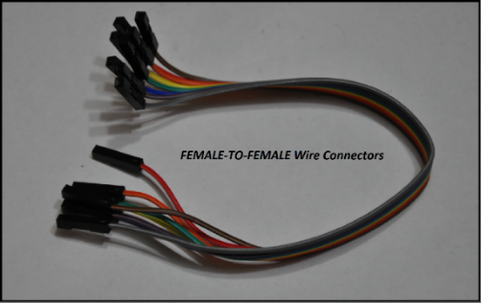

The 2-Pin Header Connectors:
You will need one of these bad-boys to select which program you want to work with. As well, you will need one to enable the four output LEDs. Lastly, you’ll need one to select which sub-mode you want to work with. This is all covered in in the below sections.
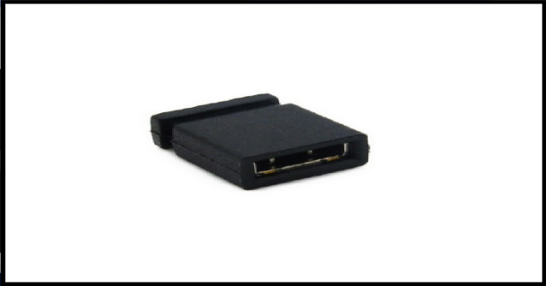

The 9v 1000mA (120-240VAC to 9VDC) AC-DC Power Adapter:
These power supplies are compatible with any input voltage between 120VAC and 240VAC (For those of you find people overseas). All you need to do is plug the AC adapter into the board. There is a 5mm power jack on the board, and the adapter plugs into the processor board directly. For those of you who have regulator boards/kits coming to you that include AC adapters, what you need to do is cut off the jack, strip back the insulation of the red and black wires, and connect them to the regulator board input terminal block. This is talked about in the below sections.
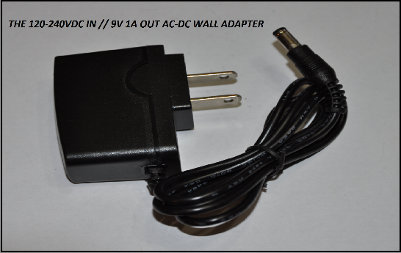

The 5mW 3v laser Module:
This little guy is about as strong as a store-bought laser point. This laser had an adjustable focus option. By gently turning the head of the laser, you can focus the beam (making it stronger, but smaller), or un-focus the beam (making the beam larger, but less powerful). It requires 3c to operate. It consumes between 15-25mA.
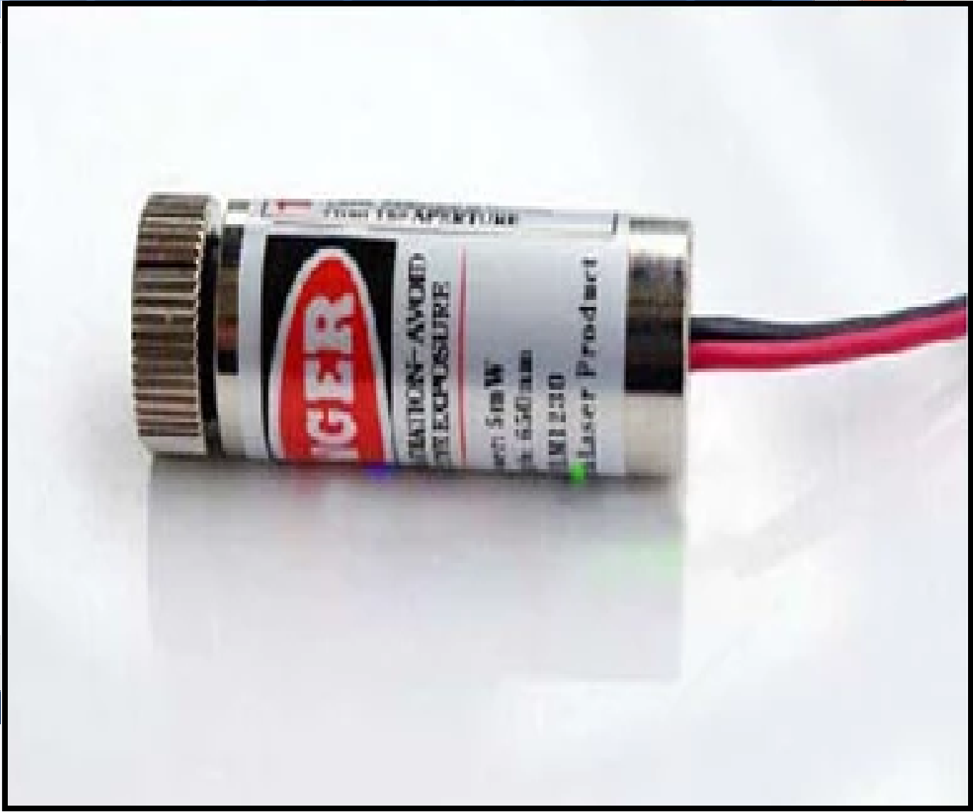

The Laser Mount:
The laser mount is an adjustable unit that can be mounted to a wall or fixture. It comes with accessories such as mounting hardware, an Allen key for bolt tightening, and a cylinder laser head module.
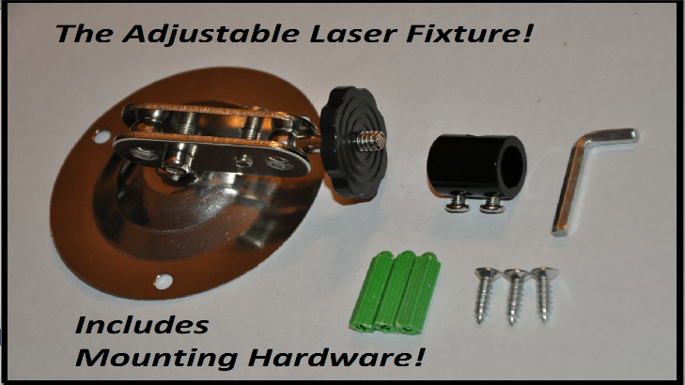

The 4-15VDC to 3VDC Regulator Board:
This board takes any voltage at the input (Between 4 - 15VDC) and regulates it down to a safe 3v for the laser to draw power from. It is very easy to use. There are solder points for the input supply voltage, and at the regulated 3v output to the laser. There is also a terminal block option for both the input and output connections. Please see the assembly video for information on how to assemble this board if you received a DIY version. When connecting your power supply, connect the positive (red) wire of the supply to the IN+ pin, and the negative (black) wire to the IN- pin. Before you connect the laser, power the unit up, and test the output for 3v. There is an ON-OFF switch in the center of the regulator board. Make sure that this is in the ON position. If you output reads 3v, then power the unit off, and connect the positive wire of the laser (red) to the 3v terminal. Connect the negative laser wire (black) to the GD pin. GD stands for ground. From there, power the unit on, make sure that the switch is in the ON position, and the laser should emit light! MAKE SURE THAT THIS BOARD IS PROPERLY MOUNTED TO SOMETHING. IT CANNOT BE LEFT JIGGLING AROUND, AS THE PINS ON THE BOTTOM OF THE BOARD MAY SHORT AGAINST THE LASER MOUNT. PLEASE SEE THE DISCLAIMER SECTION OF THIS DOCUMENT.
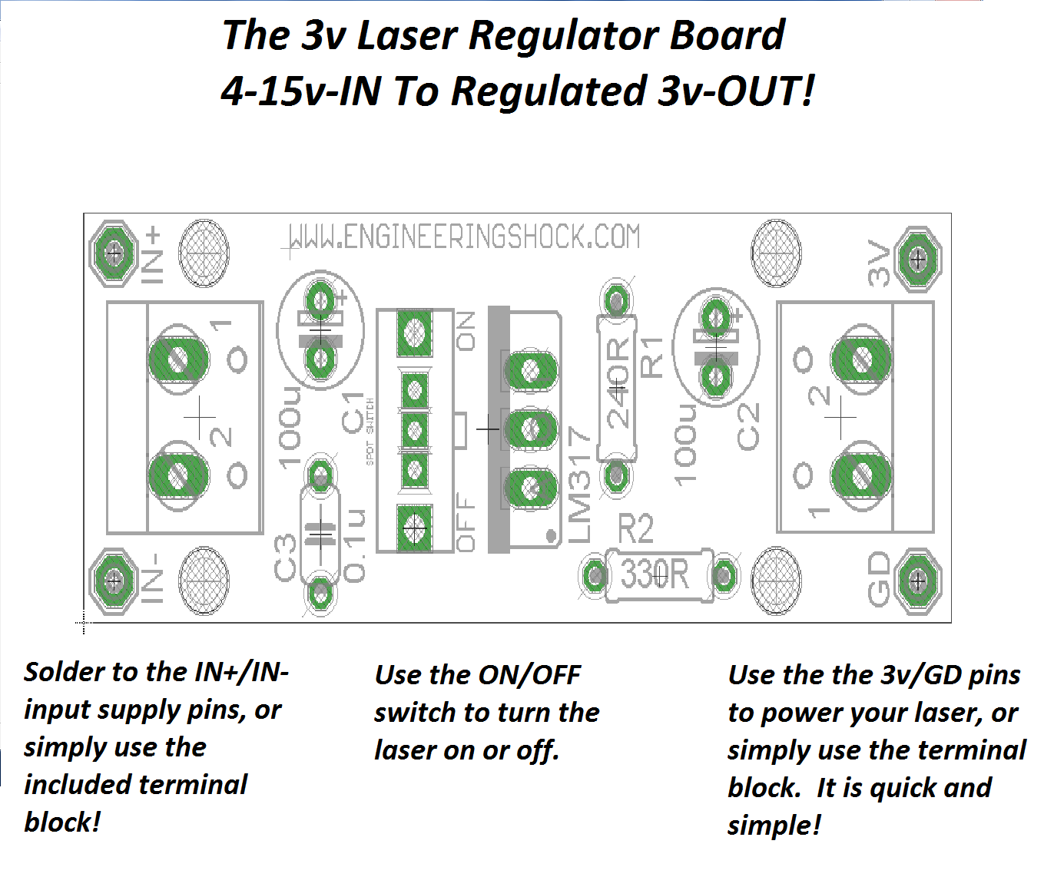

The Loud Siren:
This bad-boy can handle anywhere from 8-12VDC. It requires roughly 400mA when running. It is extremely loud, and should be respected. There are two mounting holes that you can use to mount it to a hard surface. You can also use the double-sided tape strip on the back of the siren to stick it to a surface. This is not as reliable as the mounting holes, but it does work well. It plugs directly into the processor board siren connector. Make sure that it is inserted all of the way.
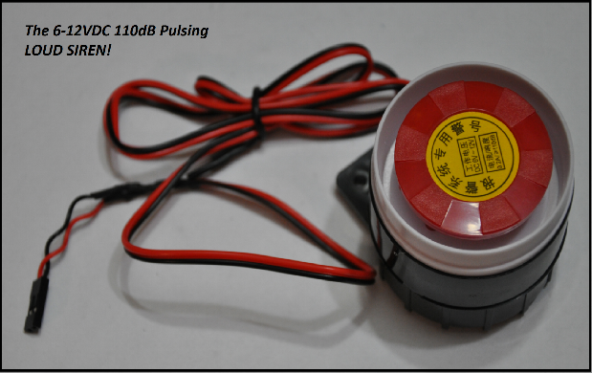

The Laser Tripwire Processor Board Diagram:
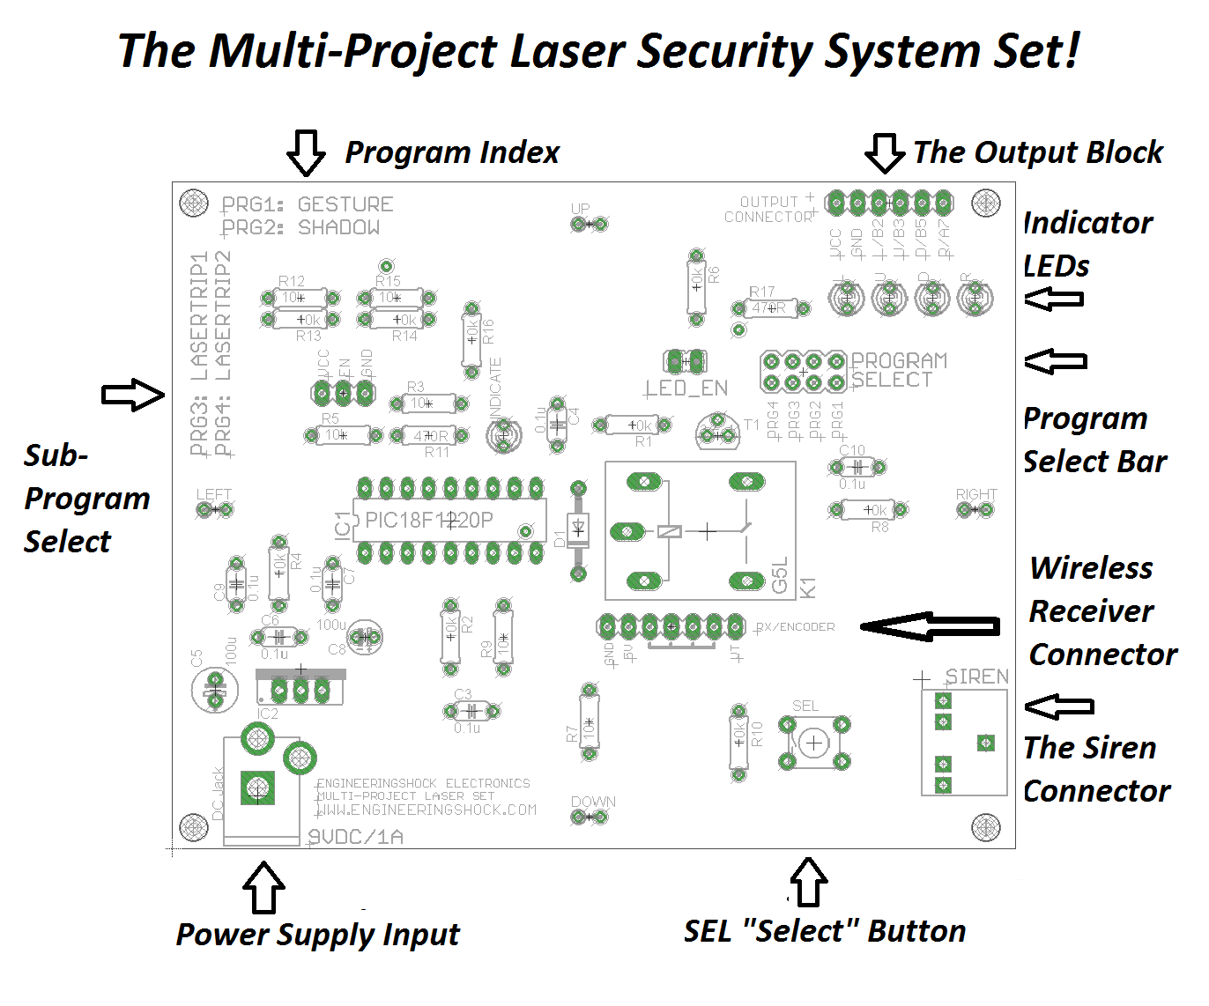

Hardware Blocks:
The Sensors are located on each side of the controller board. They are labelled UP, DOWN, LEFT, and RIGHT. These are where you point your lasers. There are mounting holes in each of the corners for easy installation.
The Program Index tells you which jumper to select on the program select bar. For instance, program#1 is the "Gesture" program. This tells us that before we power up, we need to place a 2-pin jumper on the PRG1 header.
The Sub-Program Select Header has three pins labelled VCC, EN, and GND. Of the four programs, three have secondary (sub) modes of operation. We use this jumper to choose which sub mode we want to use when using a specific program. For instance, in Shadow mode, we use this jumper to select of the output of the "R" pin is momentary or latching. All will be explained in the video and written manuals.
The Power Supply Input is merely a female DC power jack that takes power from the 9v 1A wall adapter. This is the power supply input of the device.
The SEL Button (Select Button) is used in many modes to enable the program, disable the program, or to disable the siren after an alarm has been triggered.
The Siren Connector is merely an audio connector that is used as an input for the siren. The siren has a male audio jack that plugs right into this audio connector. Like butter!
The Program Select Bar allows for us to chose which program we want to use. This has to be done prior to power up. You just need a 2-pin jumper to short the correct PRG (Program) pins.
The Indicator LEDs are used in Shadow and Gesture modes. They can be disabled or enabled by adding or removing the "LED_EN" jumper, which is located to the right of the program select bar. These LEDs are labelled L/U/D/R for Left, Up, Down, and Right. They correspond to each sensor on the board. The final LED is located just above the programmed chip, and CANNOT be disabled. This LED is specifically labelled "INDICATE". This LED is used in trip-wire modes.
The Output Block is has four outputs, a regulated 5v line, and a ground line. The regulated 5v line is called "VCC". The ground line is labelled "GND". The outputs correspond to each sensor and are used in Gesture & Shadow modes of operation. The left output is labelled L/B2, the up output is labelled U/B3. The down output is labelled D/B5. Lastly, the right output is labelled R/A7.
The Wireless Receiver Connector is a 7-pin space where you can connect the optional wireless receiver. When soldered into place, you can enable it on power-up using the SEL button. We talk about this in detail in the “Programs” section below.

The Programs:
There is a lot to say about each program. All of it is explained in detail in the video manual linked above. I'm going to leave most of the explaining for the video manual/written manual so that I can keep this short and sweet.

Program#4A/4B (Laser Tripwire#2):
This is my favorite mode of operation. This is the full-on laser tripwire mode of operation. You can use anywhere from one to four lasers on the controller board. The more lasers you use, the bigger maze are you make for yourselves. This mode can be used in normal room lighting, or in darkness. It doesn't matter. In this mode, the sensors are configured to detect fast changes in light. If one of the sensors detects that, then the alarm will sound. To enable scanning, simply press the SEL button. If you have the wireless control option, see the wireless control section of this manual. All of the LEDs will scroll to the right one time to tell you that your unit is now scanning for a change in light. The INDICATOR LED will light up, and stay on while the unit is active. When the alarm sounds, the INDICATE LED will power off after three seconds. Until this happens, you cannot disarm the alarm. The INDICATE LED turns off three seconds after the alarm is triggered. At this point, the alarm will be disabled once you press the SEL button. In program#4A, when a laser is tripped, the INDUCATE LED will cycle on and off for six seconds before the alarm is triggered. If you press the SEL button during this time, the unit will be deactivated. If you are successful in deactivating the unit, the LEDs will again scroll to the right just once. From there, you need to press the SEL button one more time to re-enable scanning. If you are in program#4B, then as soon as you trip a laser, then the alarm will sound immediately. You have to wait three seconds before you deactivate the alarm. To Select Program 4, you need to have PG4 selected on the program select jumper bar. In order to choose between program 4A and 4B, you need to place a jumper on the sub-program select jumper. For program 4A, short the EN/GND pins on the sub-program header using a 2-pin jumper. For program 4B, short the VCC/EN pins on the sub-program header using a 2-pin jumper.

Program#3A/3B (Laser Tripwire#1):
This program is also a laser-tripwire circuit. However, it is very different than program#4. In this program, we only use the bottom and/or top sensor. If we are in program#3A, then only the bottom sensor is used. In program 3B, both the bottom and top sensors are being used. Before you power your controller board up, make sure that you have laser beams lined up with the bottom sensor (3A) or both the bottom and the top sensors (3B). If you don't and you power the unit up, the alarm will sound and scare the heck out of you. When you trip with laser, the alarm will sound BUT ONLY FOR AS LONG AS YOU ARE BREACHING THE LASER! Once you move out of the way of the laser beam, the alarm will turn off. To Select Program 3, you need to have PG3 selected on the program select jumper bar. In order to choose between program 3A and 3B, you need to place a jumper on the sub-program select jumper. For program 3A, short the EN/GND pins on the sub-program header using a 2-pin jumper. For program 3B, short the VCC/EN pins on the sub-program header using a 2-pin jumper.

Program#2A/2B (Shadow):
This mode is called "Shadow" mode. This is an Arduino Compatible mode. In shadow mode, all sensors are being used at once. This mode does not require lasers. You can use them if you'd like, but they aren't necessary. This mode scans each of the sensors for a fast changes in light. In program#2A, when any change of light is detected, the R/A7 will be asserted and the R (RIGHT) LED will turn on for about 250ms, then turn off again. This is called Momentary mode. You can connect this output to your Arduino with ease to trigger an operation when motion is detected/a change of light (Such as a shadow) is introduced to the face of the board. In program#2B, whenever a fast change in light is detected, the R/A7/R LED will toggle states. For instance, one change in light will turn that output/LED on. Another will toggle it off. This is called Latching/Toggle mode. To Select Program 2, you need to have PG2 selected on the program select jumper bar. In order to choose between program 2A and 2B, you need to place a jumper on the sub-program select jumper. For program 2A, short the VCC/EN pins on the sub-program header using a 2-pin jumper. For program 2B, short the EN/GND pins on the sub-program header using a 2-pin jumper.

Program#1 (Gesture):
This program is called "Gesture" mode. This is also an Arduino compatible mode. All sensors are enabled and looking for a change in light. There is no sub-program for program#1. In this mode, if the right sensor detects a fast change in light, then the R/A7 output & "R" LED will turn on for about 250ms, then turn off again. If the upper sensor detects a change in light, then the same will happen to the U/B3 and "U" LED. If the lower sensor detects a change in light, then the same will happen to the D/B5 and "D" LED. If the left sensor detects a change in light, then the same will happen to the L/B2 and "L" LED.

How to Enable Wireless Control:
If your purchase included a wireless transmitter key fob and a wireless receiver board, then you can choose to enable wireless control. When you enable wireless control, you can activate/deactivate, and shut off the laser tripwire modes by pressing any button on the transmitter, then letting go after one second. If the receiver board is soldered into place, then when you power up in either Laser Tripwire#1/Laser Tripwire#2 mode, hold down the SEL button for one second. Remember, this must be done as soon as you power the processor board on. So hold down the SEL button, power the unit up, wait one second, then let go. The U/L/D/R LEDs should all scroll to the right three times if you’ve done this correctly. This acts to tell you that the wireless receiver is now synced with the board. Now, you can activate, deactivate, and shut off the siren once breached with the touch of a button. To get the best distance, make sure to extend the antenna on the wireless transmitter key fob.

How to Connect To Arduino:
The neat thing here, is that as long as you don’t are not in laser tripwire modes 1 or 2, then you can actually power the board with your Arduino. In order to do this, make the following connections:
Connect the GND pin on the output block to one of the GND pins on your Arduino UNO. From there, connect the VCC pin on the output block to the 5v pin on your Arduino UNO. Make sure that you do not have these reversed!!! To test this, make sure that you are in an area with decent lighting. Make sure that you have either PG1 or PG2 selected. Sub programs do not matter for this test. Make sure that you have the LED-EN header shorted with a jumper. Plug in your Arduino, and the Shadow/Gesture modes should work perfectly, as the UNO is powering the processor board.
From there, you can connect any of the outputs (Left/Up/Down/Right) to any GPIO pin on your Arduino UNO.
You don’t have to do this. If you want to keep your processor board powered using the AC adapter, then the only connection that you need to make between the two boards is the ground connection. The GND pin on the processor board must be connected to the GND pin on the Arduino UNO. Then both units can communicate, but using separate power sources.
Alternately…. You can use the processor board to power the Arduino UNO! Write your program, and be free of your computer! Connect the GND pin on the output block to one of the GND pins on your Arduino UNO. From there, connect the VCC pin on the output block to the 5v pin on your Arduino UNO. Make sure that you do not have these reversed!!! These are the same connections that we made before. From here, you can connect the AC adapter to the processor board, and this will properly power both the Arduino UNO and the Processor Board. Neat, eh?

Sample Code:
Use this code with your Arduino UNO. For this code to be used, you do not need to use the power supply to the processor board. You can use the 5v line from your Arduino to power the processor board. Make sure that you power up the unit in Gesture mode. Make the following connections:
Processor Board Connects To Arduino Uno
VCC 5v
GND GND
L (Left) GPIO#4
U (Up) GPIO#5
D (Down) GPIO#6
R (Right) GPIO#3

Plug your Arduino UNO into your PC, and upload the code below to automatically run the script. Once running, open the serial monitor on your Arduino UNO. When any of your four sensors detects a change in light, the serial monitor will tell you which sensor has detected a breach/change in light. You can use lasers on each of the sensors if you’d like. If you do this, then the serial monitor will tell you which sensor has detected a laser tripwire breach.

Code:

The Schematic Diagrams:

The Processor Board:
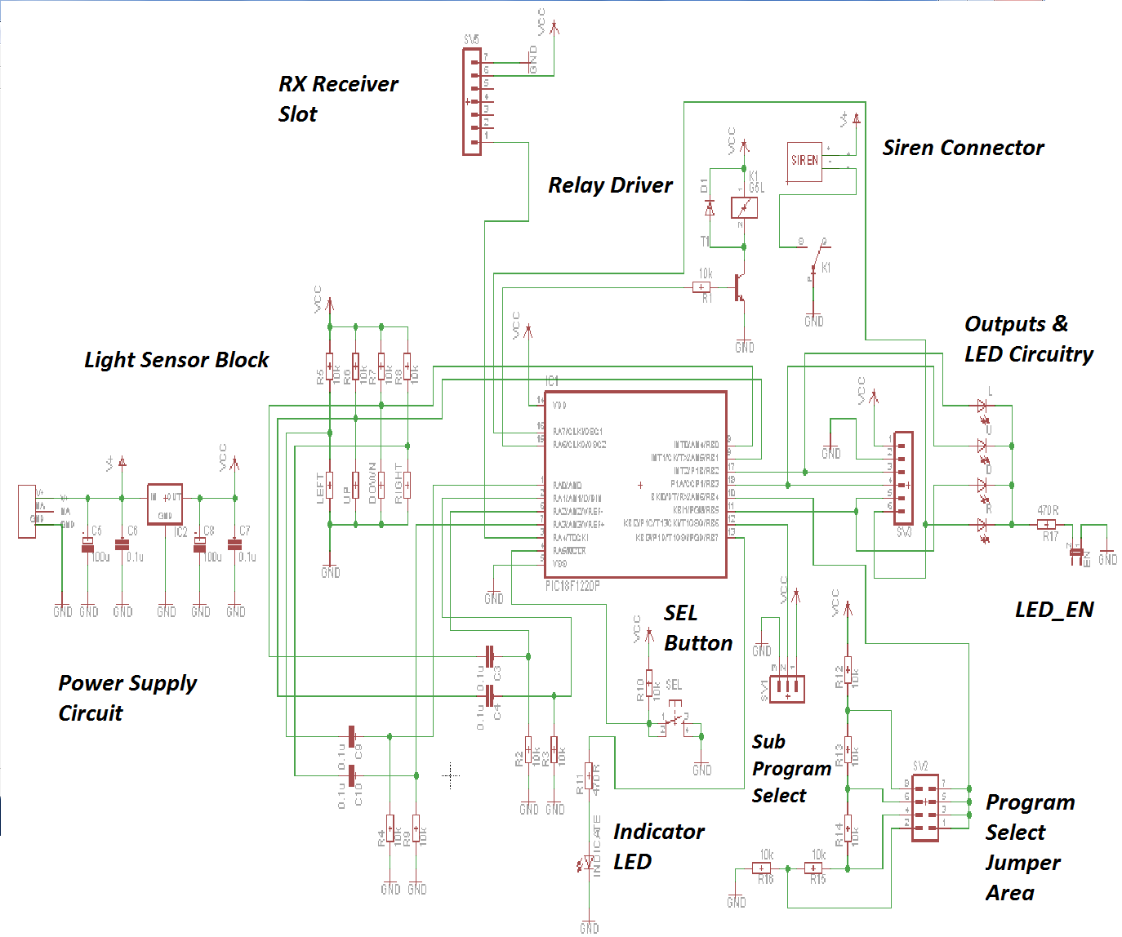
PDF Download:

The 3v Regulator Board:
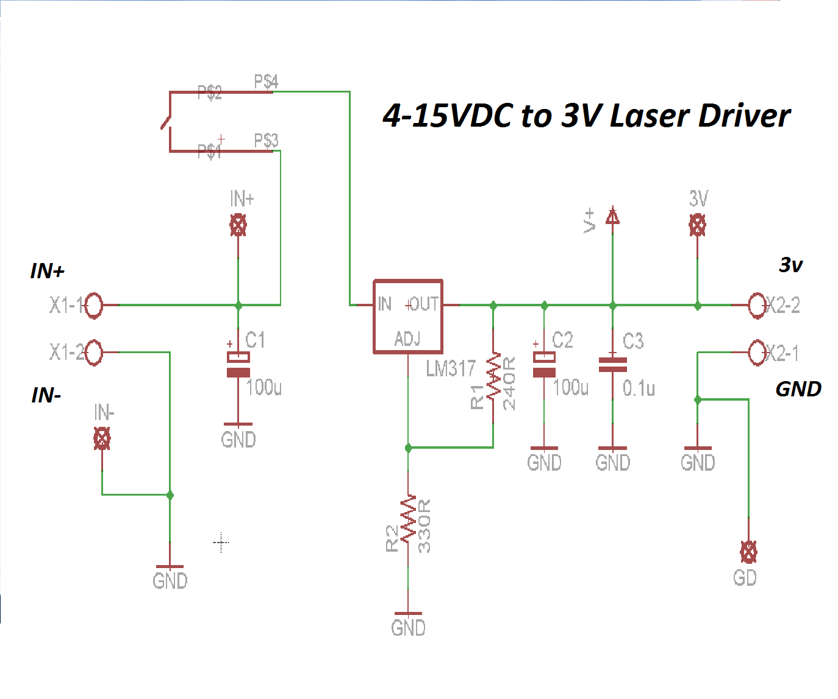
PDF Download:
Mirrors:
Mirrors work great with this set. There are a few things to consider here, and I have a few tips to offer. First of all, if you want to purchase some inexpensive mirrors, most dollar stores, or dollar-related stores will offer mirrors that have adhesive on the back. I purchased some make-up mirrors with adjustment for $3 a piece! They work great! If you have a small mirror that you want to use, and you want to have it on an angle on the wall, you can use putty, but keep in mind that putty will settle over time, and this can cause issues when a laser is lined up to a sensor through a mirror. As the putty settles, it can cause misalignment. I just wanted to share this, as it has caused me some grief in the past. Make sure that the mirrors are as clean as humanly possible. When the laser bounces off of a mirror surface, it loses a tiny bit of power. It is always best to line up a laser to a sensor through a mirror (or a few mirrors) then focus the laser beam so that the beam is as strong as possible. If you have four lasers, four mirrors per laser, some patience, and some time to spare, then you can make a really RAD laser grid! When in any of the tripwire modes of operation, it is always best to operate in low-light or dark areas.

Precautions & Warnings:
- Make absolutely certain that your processor board, your regulator boards, and your laser mounts are properly mounted before use. If the leads on the bottom of any of the PCBs are shorted against any kind of conductor, you can not only damage the circuitry, but also potentially start a fire. When a power supply short occurs, the power supply can get very hot, as it is sourcing all of the power that it can muster. This can result in a damaged power supply and potentially and electrical fire caused by excessive heat.
- Make sure that you do not aim the lasers into the eyes of any human or animal. The included lasers are rated for 5mw, and while this will not immediately blind someone, it can do damage quickly if the beam is aimed into an eye for even a few seconds. Keep this in mind when setting up your laser grid.
- Make sure that when you make power supply connections; especially when concerning the regulator board, that you make sure that no exposed wire is showing. Make sure that you tighten the terminal blocks properly so that the wires cannot easily be removed. This will ensure safe operation.
- The siren is extremely loud. It should be advised that this units should not be used near small children. The siren is so loud that it can damage your ears, or the ears of your friends or loved ones if exposed for more than a few moments.

Disclaimer:
This project board is, quite simply put, a project board. It is a conversation starter. It is a lot of fun to work with. This unit is not being sold as a security system. It should not be used in place of a commercial security system. I will not be held accountable and accept no responsibility for theft or damage. This set is meant for mature adults. It should not be used to startle or scare people. The lasers should not be used to aim into the faces of people or animals. I will not be held accountable and accept no responsibility for injury to people or animals. This unit should be used with caution. All hardware should be mounted with care. I will not be held accountable for fire or electrical damage. Use this unit with care and maturity in mind.

Many Thanks!
Many thanks for pledging to this kickstarter campaign/purchasing this set from my websites. I do appreciate your patronage! I hope that you enjoy working with this set, and that it gives you many, many hours of amusement! Take care, and thanks again for taking the time to read through this document.

